To Download Torrent:
http://www.utorrent.com/downloads

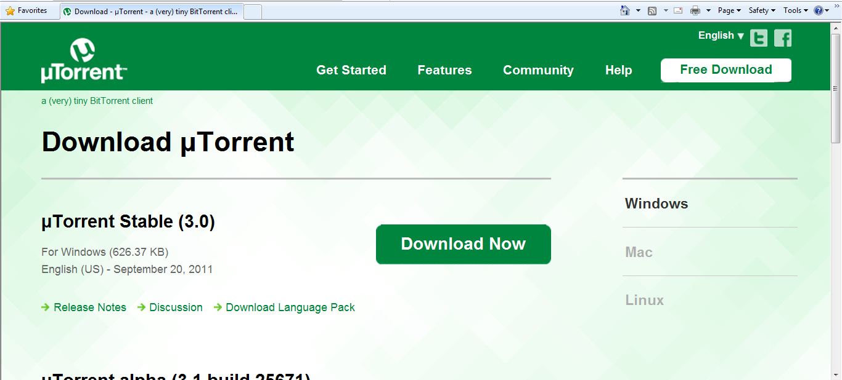

Download Ubuntu
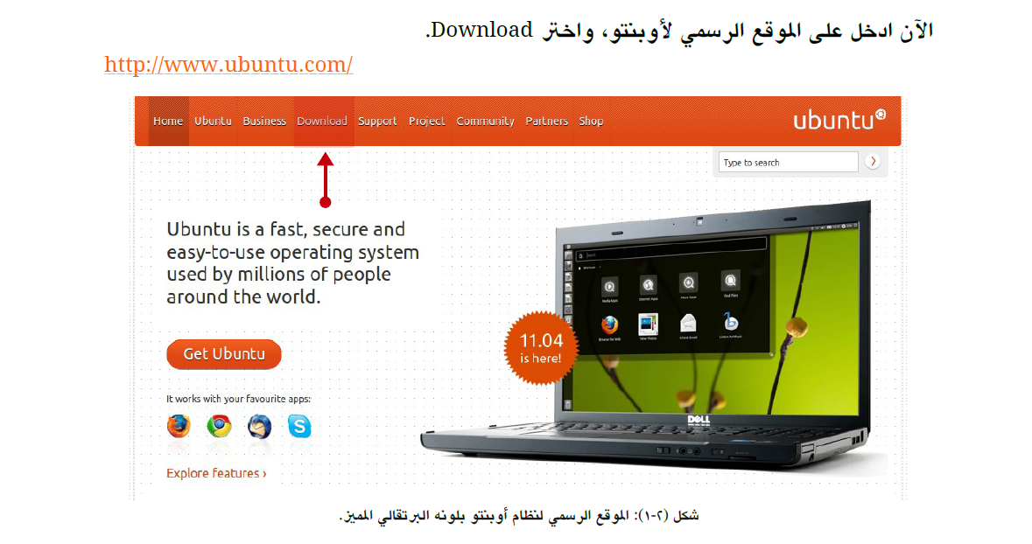
http://www.ubuntu.com

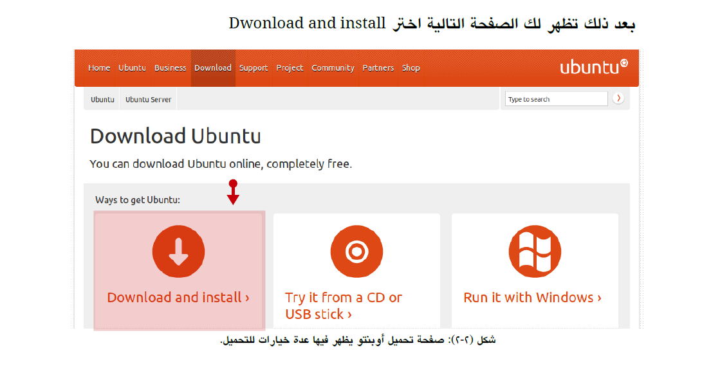
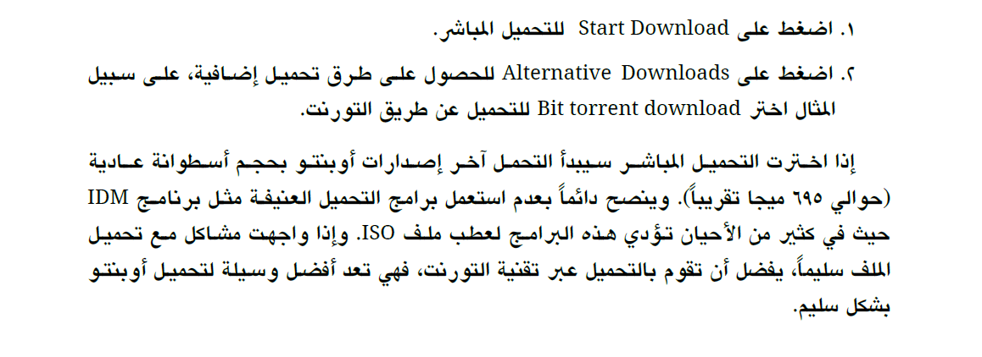
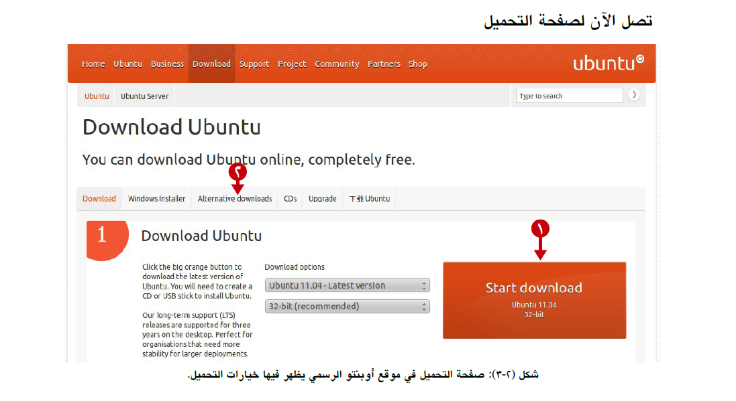
في حال الاختيار الثاني ( التحميل عن طريق التورنت ) تظهر الشاشة التالية:
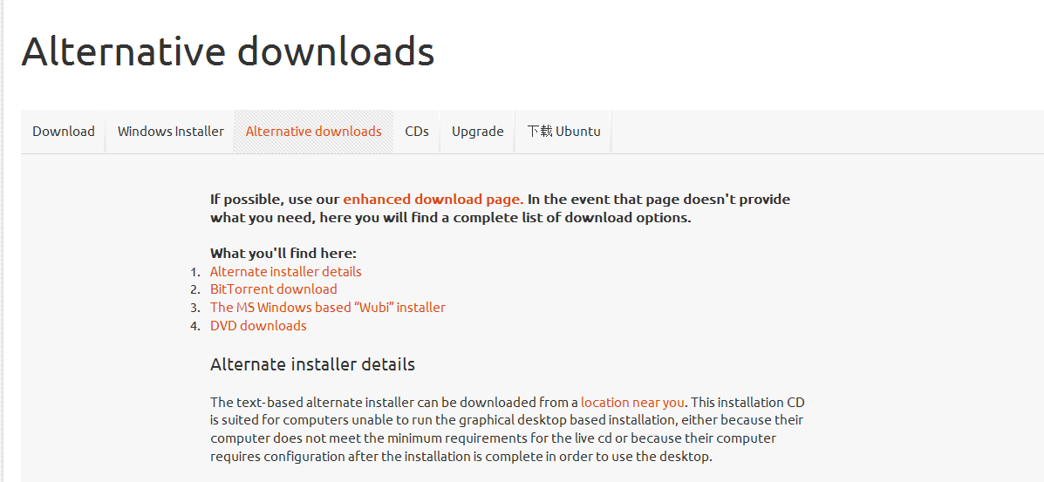

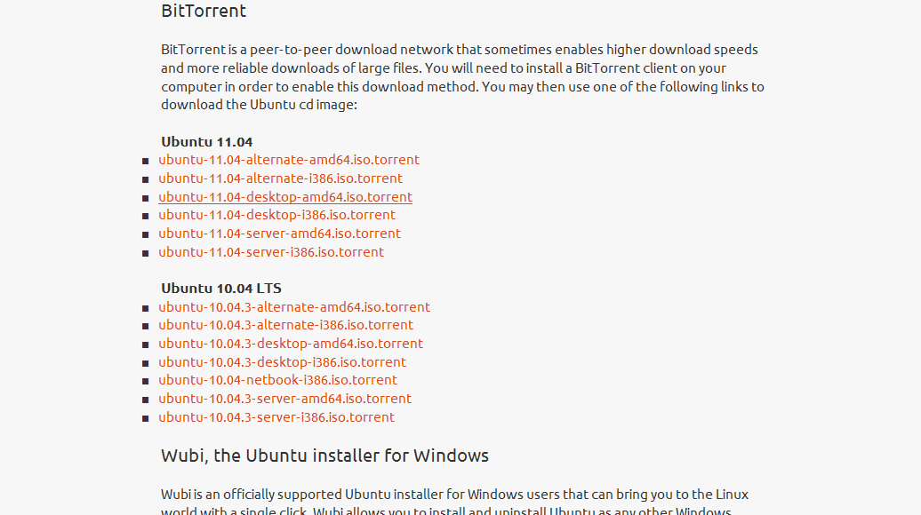
نختار(BitTorrent download) تظهر الشاشة التالية :

ubuntu-11.04-desktop-i386.iso.torrent
نختار هذا الملف هو الأنسب تقريبا في حال كان نظام التشغيل 32 bit
ubuntu-11.04-desktop-amd64.iso.torrent
نختار هذا الملف هو الأنسب تقريبا في حال كان نظام التشغيل 64 bit

بعد حفظ الملف سيفتح التورنت تلقائيا ويطلب منك الإذن في البدء بعملية التحميل و يأخذ مدة زمنية تعتمد على سرعة الاتصال لديك

Burn your CD , DVD or create a USB drive
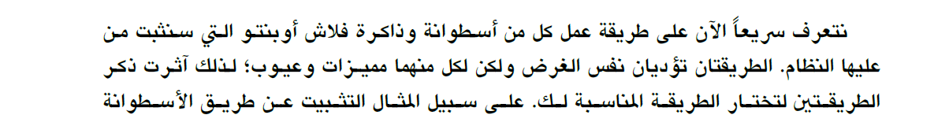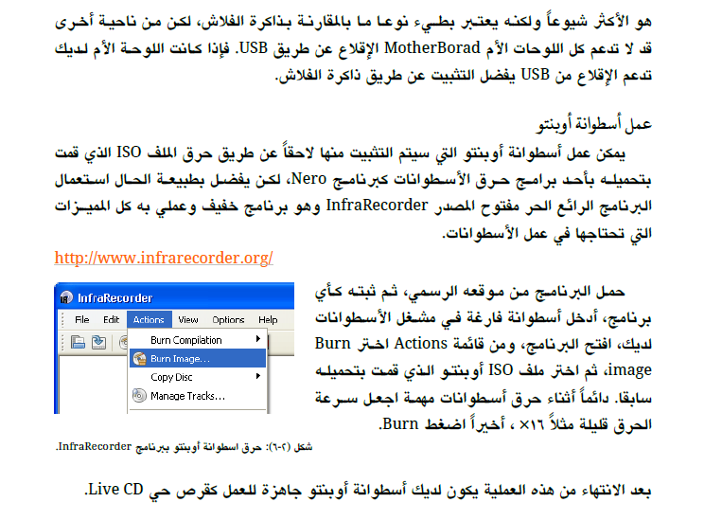
http://infrarecorder.org/?page_id=5

رابط الموقع :
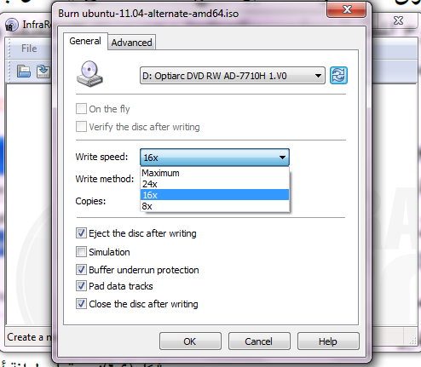
هنا كيفية اختيار سرعة الحرق :

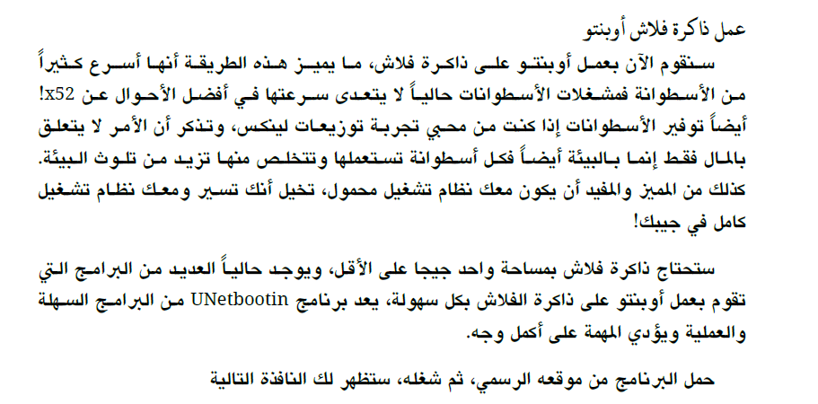
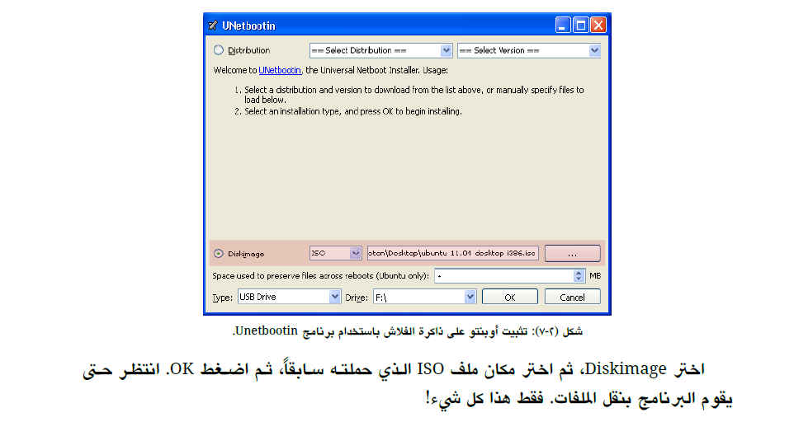

رابط تحميل البرنامج : http://unetbootin.sourceforge.net /

How to access the BIOS utility
if you restart and doesn’t see the Ubuntu welcome screen, you have to edit the BIOS settings and change the boot order.(to change the boot order you need to access the BIOS setup utility.)
The most common way to enter the BIOS is to press the DELETE key when the computer is first booted(this seems to be becoming standard). On other systems it could be a different key, or combination of keys like ESC, F1, F2, F10, F12, Ctrl-Esc, Alt-Esc, Ctrl-Alt-Esc, Ctrl-Alt-Enter, Ins or even others. You might have to press, press and hold, or press multiple times. The best way to find out the details of that is to look in the users manual or search the manufactures website
- A typical BIOS boot menu screen
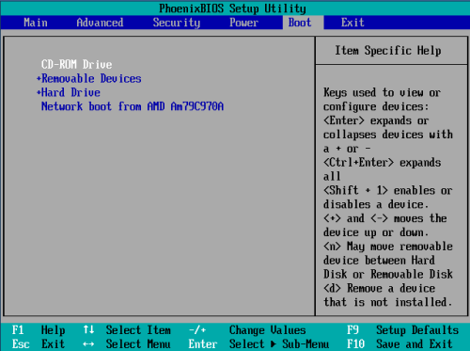
Some computers require you to hold down or press a key to enable booting from the CD drive, the best place to find this information is in your computers user manual or the manufactures website. Here are some common keys to try if you lack that information.
- Apple Computers and others: Hold down the C key while rebooting. Toshiba, IBM and others: press F12 while booting to get to the boot menu and choose CD-ROM. Asus and others: press TAB key while booting and select CD-ROM from boot menu.
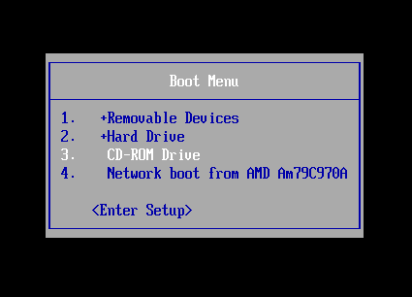

For more information Read this : https://help.ubuntu.com/community/BootFromCD
OR this: http://pcsupport.about.com/od/fixtheproblem/ht/accessbios.htm

Ubuntu welcome screen
2

Note:
If you faced any problem try to download Slax:
http://www.slax.org/get_slax.php

For Mac users:
1- Open BitTorrent application
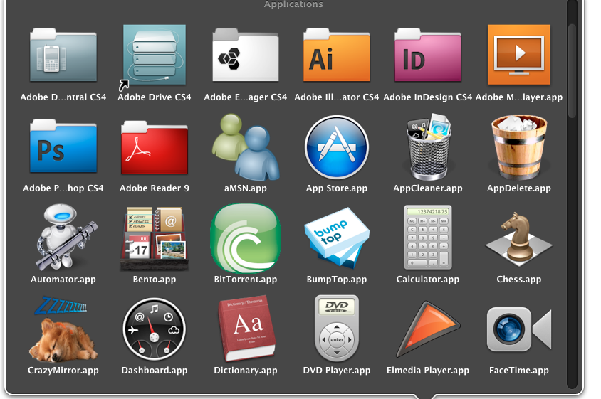

Note that the .iso.torrent file name differs from what is shown in the website depending on the version:
- ubuntu-11.04-desktop-i386.iso.torrent
OR
- ubuntu-11.04-desktop-amd64.iso.torrent
2- Click add button(+)
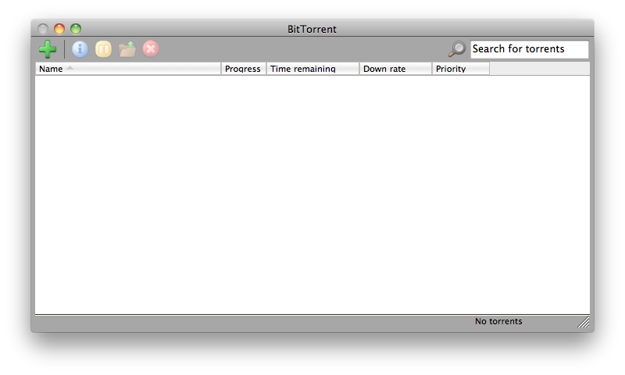
3- Add the torrent file by clicking Browse button

3- Click OK
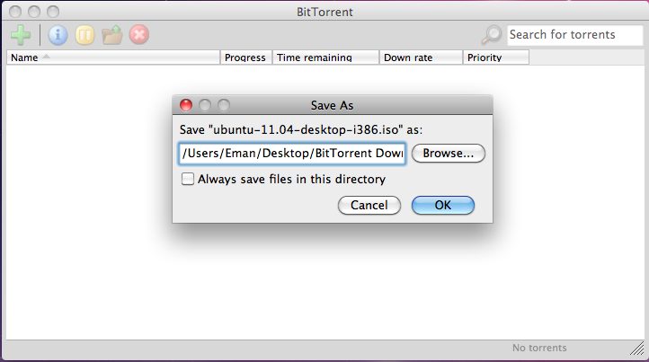

4- The downloading will start
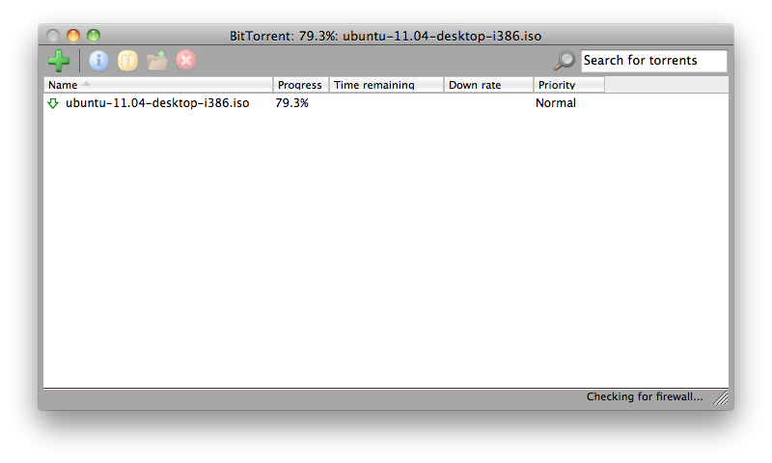
5- When finishing download, You will get the .iso file

6- Now, burn the .iso file to CD
- Insert your CD or DVD.
- Open the Disk Utility. (Applications → Utilities → Disk Utility).

7- Burning the CD
- How to Burn using the Disk Utility?
Follow the details in Step2 in this link:
http://www.ubuntu.com/download/ubuntu/download
8- After Burning
- When burning completes, insert the CD then restart.
- How to Boot from CD on Mac?
Press C key when restart.
Then you will get the welcome screen as in Step 3 in this site:
http://www.ubuntu.com/download/ubuntu/download

